**Data types:**

variables: value is assigned, should start with letter

Strings**:** “ “

Numbers: integers, float(3.54),char, varchar,

**Data operation:**

**Indexing:** getting the desired single value

Elephant[0]=E

Elephant.index(‘l’) returns the position of l

=1

***Find

'herarakokn'.find('r',3)********.find is a method

=4

**Slicing:[**start,stop,step]

[:],[:-1]

animal=("elephant")

print(animal [0:2])#slicing, starts with 0,and -1 if started from the end

**logical operators:**

+,-,/**,%<,>,==,!=,

**Boolean operators**

True, False (everything converts to true or false)

0,1

**Boolean logical operators**

**and , or,not**

**Data structure/type**

**List**

A=[‘what’, ‘is’, ‘’going’, ‘on’], A[0]=what, A[-1]=on

**** ‘what is going on.split(‘ ’)== creates a list from string

****reverse[;:-1]

****.append(8) adds on the list

**Dictionaries:**

**Stores a key with a value,**

{key:value, key2:value2}

Dict={phone1:333-222-111}

phonebook={"ram":["8-225-5556","email1","heigt1"],"hari":"318-222-771"}

print(phonebook['ram'][1])''

**Tuples:**

Immutable

Like a list that cannot be appended.

>>> x=(10,10,10)

>>> x.append(20)

Traceback (most recent call last):

File "<pyshell#2>", line 1, in <module>

x.append(20)

AttributeError: 'tuple' object has no attribute 'append'

**Statements:**

**If statement:**

Else does not take a condition, it runs by default

if 5<2 and 7>4:

print(4+1)

elif 5!=5 or not(5)!=5:

print(3)

else:

print(“else does not take conditions”)

**Functions**: def square (argument1 , argument2):

Def numbers(a,b=6), sets b (formal argument) as 6 as default value

X=a+b

Def number(5,6) (5,6) is a actual argument

**Variable length**

Def number(a,*b): when the number of second argument is not known,,, added as tuple

(a,**b): gives b 2 variable length : key and value pair…def(2, age=3,home=”ktm”)

*Square (10,20) # calling the function

*Arguments can be list

\**>>> assert 4==4 (test statement)*

*>>> assert 4==5*

*Traceback (most recent call last):*

*File "<pyshell#1>", line 1, in <module>*

*assert 4==5*

AssertionError

\***return VS print**

**Return= return the value of function to a assigned variable**

Print= prints the desired value

*>>> def return111(x):

print(x+5)

return(x*4)

>>> return111(5)

10

20

>>> df=return111(5)

10

>>> df

20

**Recursion:** function calling it self…. Best to be used with loops

**Lambda:** f( ):=lambda(a:a*a)…..sets function which allows the operation on the same line of code

**Map,filter.**

Map(f,data): to connect data with the function

Filter: to select required datas

filter(f,data)

reduce

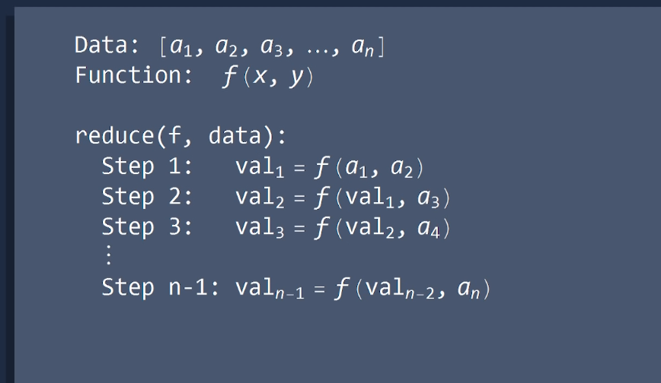

**Loops:**

**for loop**: takes a list (finite)

range(start:stop)

range(5)= creates a list [0,12,3,4]

**while loop:** (usually used when end is not known, not necessary to specify the range)

count=2

sumfun=0

while(count>0):

sumfun=sumfun+count

count=count-1

print(sumfun)

**libraries**

**import**

**can be used to call libraries and other modules.**

**From Calc import* (importing the module calc)**

**If do not want to call the whole module…..can be used as calc.add(argument1,argument2)**

**random: randomly chooses**

**return random.choice([a,b,c,d])**

randomly chooses between a, b,c,d

**Turtle**: library used for graphic window(GUI, graphic user interface)

Import turtle

Sturt=turtle.Turtle() # this is setting sturt with lib turtle and calling the Turtle function with turtle.